
Facilitator Guide

Module 5 – Computing Theory
Occupational Certificate: Artificial Intelligence Software Developer

Module # | 251201-002-00-KM-05
NQF Level | 4
Notional hours | 80
Credit(s) | 8
Curriculum Code | 251201002
Qualification Title | Occupational Certificate: Artificial Intelligence Software Developer

CONTACT INFORMATION:
Name
Contact Address
Telephone (H)
Telephone (W)
Cellular

PURPOSE OF THE KNOWLEDGE MODULE
The main focus of the learning in this knowledge module is to build an understanding of programming as creating a set of instructions for a computer on how to perform a task, using coding and programming languages

PROVIDER ACCREDITATION REQUIREMENTS FOR THE MODULE:

Physical Requirements:
- The provider must have lesson plans and structured learning material or provide learners with access to structured learning material that addresses all the topics in all the knowledge modules as well as the applied knowledge in the practical skills.
- QCTO/ MICT SETA requirements
Human Resource Requirements:
- Lecturer/learner ratio of 1:20 (Maximum)
- Qualification of lecturer (SME):
- NQF 6 in industry recognised qualifications with 1 year’s experience in the IT industry
- AI vendor certification (where applicable)
- Assessors and moderators: accredited by the MICT SETA
Legal Requirements:
- Legal (product) licences to use the software for learning and training (where applicable)
- OHS compliance certificate
- Ethical clearance (where necessary)
Exemptions
- No exemptions, but the module can be achieved in full through a normal RPL process

TOPIC ELEMENTS TO BE COVERED INCLUDE:

- KM-05-KT01 : Introduction to programming languages
- KM-05-KT02 : Introduction to algorithms
- KM-05-KT03 : Programming basics
- KM-05-KT04 : Solution development
- KM-05-KT05 : Introduction to Python

SECTION 1: KM-05-KT01: Introduction to programming languages

What is computational thinking and how does it relate to programming?
Computational thinking is the step that comes before programming. It's the process of breaking down a problem into simple enough steps that even a computer would understand. We all know that computers take instructions very literally, sometimes to comic results.

What is the difference between programming and computational thinking?
Coding and Computer Science
While computational thinking is the problem-solving process that can lead to code, coding is the process of programming different digital tools with algorithms. It is a means to apply solutions developed through the processes of computational thinking.

What do all computer programming languages do?
Computer programming languages allow us to give instructions to a computer in a language the computer understands. Just as many human-based languages exist, there are an array of computer programming languages that programmers can use to communicate with a computer.

Why is logic important in programming?

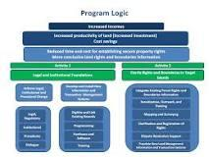

Developing a clear and well-defined program logic—the chain of events by which a given project is expected to lead to increased household income—is a crucial step in designing MCC projects. The clearer a project's program logic, the easier it is to design activities, implement them, monitor them, and evaluate results.

What is object-oriented programming best for?
Object-oriented programming is an approach that involves defining data structures as objects that can contain data and methods. This approach is well suited to large, complex applications that need to be updated frequently.

Explain how to choose a programming language?
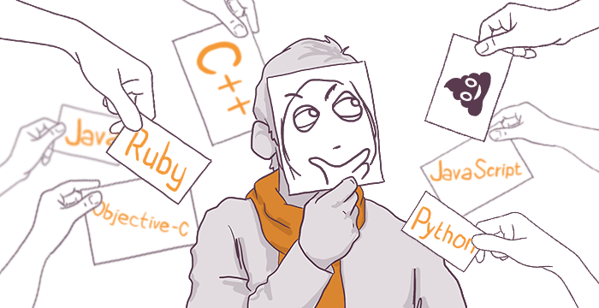
By different estimations, the number of production-ready programming languages in the world varies from 400 to 600. And at least two orders of magnitude more experimental projects. How to make a good choice, having so many options? How to choose a language, which not only will turn out to be commercially in demand but also will bring joy in everyday practice? How will this choice show itself in the long-term?
The criteria of choosing the first and the N-th language differ radically. This article describes the process of choosing the first language. What is meant by "the first" language? The one in which you can fulfill commercial orders! That means, if you have read something about a dozen of languages, but can't make it to the Junior in every of them, – this article can be useful for you.

Explain the followin AI programming languages:
The origin of Artificial Intelligence (AI) dates way back in time. So, it is safe to say that it is not an innovation in the year 2022. We have witnessed, used, and gotten used to this area of technology and it is getting better day by day.

JAVA
Java by Oracle is one of the best programming languages available out there. Over the years, this language has adapted to the latest innovations and technological advancements. The same is true for AI. Using Java for AI development can help you get some scalable applications.

PYTHON
Another one on the list is Python, the programming language that offers the least code among all others. There are many reasons why Python Development Companies are preferred the best for AI development. These reasons include:
- Prebuilt Libraries for advanced computing like Numpy, Scipy, and Pybrain.
- Open-source language with support by developers from across the world. There are many Forums and Tutorials for Python that you can seek help from.

LISP
Lisp is one of the oldest languages used for AI development. It was developed in the 1960s and has always been an adaptable and smart language. If your project requires modification of code, problem-solving, rapid prototyping, or dynamic development, Lisp is for you.

PROLOG
Prolog is short for Programming in Logic. The language was developed in 1972 in a rule-like form. It is majorly used for projects that involve computational linguistics and artificial intelligence. For the projects that require a database, natural language processing, and symbolic reasoning, Prolog is the best bet! It is the perfect language support for research when it comes to artificial intelligence.

C++
One of the major advantages of having C++ as your AI programming language is processing speed. When you consider AI processes, you talk about complex automated solutions to run efficiently. And, C++ won’t disappoint you in that respect. However, C++ is not a preferred language for leading Companies in AI. The reason behind that is the complex syntax and limited range of libraries.
This is where C++ has another important feature to attract a wide range of companies, its cost-efficiency. C++ will provide a cost-efficient AI solution to fit your requirements when compared to other AI programming languages. Other than that, we can use C++ for OpenCV, which is one of the widely used open source libraries of computer vision.

SECTION 3: KM-05-KT03 : Programming basics

What are the basics of algorithms?

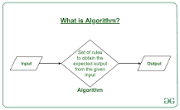

Algorithm Basics. The word Algorithm means “a process or set of rules to be followed in calculations or other problem-solving operations”. Therefore Algorithm refers to a set of rules/instructions that step-by-step define how a work is to be executed upon in order to get the expected results.

What are the 5 basic data types?
Most modern computer languages recognize five basic categories of data types: Integral, Floating Point, Character, Character String, and composite types, with various specific subtypes defined within each broad category.

What is a variable in programming example?
Variables are data values that can change when the user is asked a question, for example, their age. Variables may change during program execution. A variable is a memory location .

What are if statements conditionals and if else statements?
“If” statements: where if a condition is true it is used to specify execution for a block of code. “Else” statements: where if the same condition is false it specifies the execution for a block of code. “Else if” statements: this specifies a new test if the first condition is false.

Javascript Conditionals
Conditional statements control behavior in JavaScript and determine whether or not pieces of code can run.
There are multiple different types of conditionals in JavaScript including:
- “If” statements: where if a condition is true it is used to specify execution for a block of code.
- “Else” statements: where if the same condition is false it specifies the execution for a block of code.
- “Else if” statements: this specifies a new test if the first condition is false.
Now that you have the basic JavaScript conditional statement definitions, let’s show you examples of each.
// Learn How to Become a Web Developer with Pluralsight Skills

What are the 3 types of loops in programming?
In Java, there are three kinds of loops which are – the for loop, the while loop, and the do-while loop. All these three loop constructs of Java executes a set of repeated statements as long as a specified condition remains true. This particular condition is generally known as loop control.

What is an array in programming with example?

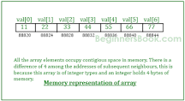

An array is a group (or collection) of same data types. For example an int array holds the elements of int types while a float array holds the elements of float types.

What are characters in coding?
Every letter, digit, and punctuation mark is a character.
There are also many characters that are invisible on screen, such as the space, tab, and carriage-return characters. Most programming languages provide a data type called 'character' or 'char'.

What is function in programming with examples?
The function contains instructions used to create the output from its input. It's like a cow that eats grass (the input) which its body turns into milk which a dairy farmer then milks (the output). For example, programming functions might take as input any integer or number.

Explain input and output with examples.



An input is data that a computer receives. An output is data that a computer sends. Computers only work with digital information. Any input that a computer receives must be digitised. Often data has to be converted back to an analogue format when it's output, for example the sound from a computer's speakers.

SECTION 4: KM-05-KT04 : Solution development

Discuss the principle of software development

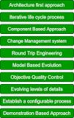

Model-based evolution is an important principle of software development. A model-based approach supports the evolution of graphics and textual notions. Objective Quality Control: The objective of quality control is to improve the quality of our software.

What is software development tools and techniques?
A programming tool or software development tool is a program or application that software developers use to create, debug, maintain, or otherwise support other programs and applications.

What are the 5 stages of computational thinking?

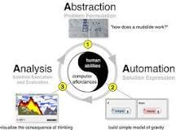

Characteristics
- Abstraction: Problem formulation;
- Automation: Solution expression;
- Analysis: Solution execution and evaluation.

Selection is a programming construct where a section of code is run only if a condition is met. In programming, there are occasions when a decision needs to be made. Selection is the process of making a decision. The result of the decision determines which path the program will take next.

SECTION 5: KM-05-KT05 : Introduction to Python

What is native data type?
Signed integer types: signed char, short, int, long. Unsigned integer types: unsigned char, unsigned short, unsigned int, unsigned long. Floating point types: float, double, long double. Special type: bool (has values true and false)

What are the 4 data types in Python?

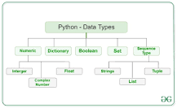

Python Data Types
- Numeric.
- Sequence Type.
- Boolean.
- Set.
- Dictionary.

What are special methods in Python?

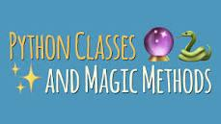

In Python, special methods are a set of predefined methods you can use to enrich your classes. They are easy to recognize because they start and end with double underscores, for example __init__ or __str__ .

What is array manipulation in Python?
Data manipulation in Python is nearly synonymous with NumPy array manipulation: even newer tools like Pandas (Chapter 3) are built around the NumPy array. This section will present several examples of using NumPy array manipulation to access data and subarrays, and to split, reshape, and join the arrays.

Explain array in Python with example?

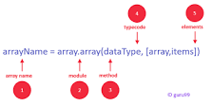

A Python Array is a collection of common type of data structures having elements with same data type. It is used to store collections of data. In Python programming, an arrays are handled by the “array” module. If you create arrays using the array module, elements of the array must be of the same numeric type.

